GGPC COVID19 Management Plan
Resumption of Gearys Gap Pony Club Activities

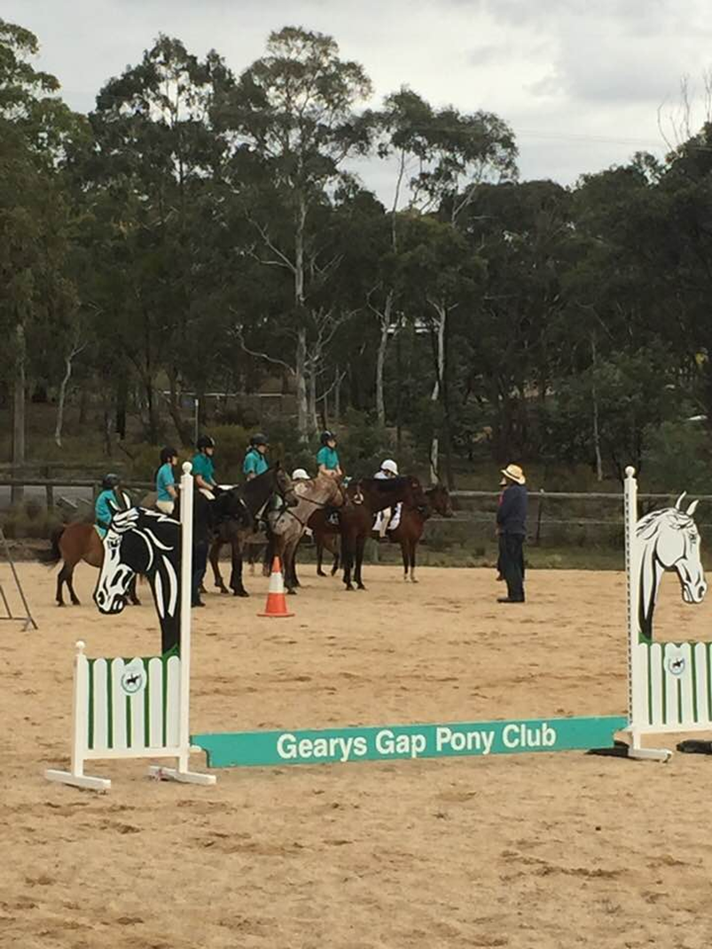

Overview
NSW Guidance. Gearys Gap Pony Club have confirmed with Pony Club Association of New South Wales (PCANSW) that the easing of restrictions as announced by the Premier on the 10th May 2020 apply to sporting organisations for training purposes only and therefore we can confirm that GGPC may return to sport for training activities only whilst following the NSW Public Health Orders.
Club Guidance. Members will be reminded prior, during and after Gearys Gap Pony Club activities that they must comply with PCA NSW, NSW Health Guidelines, NSW Public Health Orders, complete COVID-19 declaration forms and follow all directions from Gearys Gap Pony Club Committee to ensure members position is not compromised in the event of a claim. Gearys Gap Pony Club does not want our club to become a COVID19 cluster and will uphold the health and well-being of our members and community. As such, we will implement a phased resumption to GGPC activities as per this plan, upkeep the necessary administration for tracking purposes and execute the risk management plan at Enclosure 1 below.

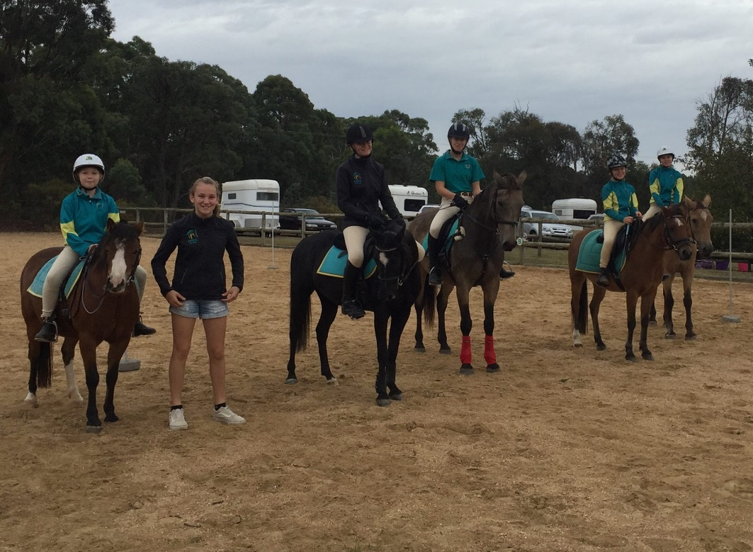

Phase 1 – 13 July 2020
Group Size. GGPC group numbers limited and scheduled to outdoor gatherings guidelines of 10 people - Group includes Coaches, instructors, and helpers.
Bio-Security. GGPC will implement extra bio-security procedures
Health Orders. GGPC Officials and members will adhere to all NSW Public Health Orders which includes strict social distancing and hygiene practices
PPE. GGPC will stock added PPE to include soap, hand sanitizer, gloves, toilet cleaning.
Facilities. No use of club house (Hall) – toilet use only. Signage as per Enclosure 2 below.
Lesson Equipment. No shared use of equipment, dedicated set up/pack up team (gloves on).
Member Health Declaration. All attendees will complete COVID19 PCANSW Self Declaration Form as per Enclosure 3 below. Committee to document and record all attendees.
RSVP. No RSVP prior to attendance, no ride. Includes everyone attending the activity.
COVID19 App. Recommend download and use for GGPC activities.
Entry/Exit. Single entry/exit for riders onto grounds.
Canteen. BYO food and drinks. Including water bottles.

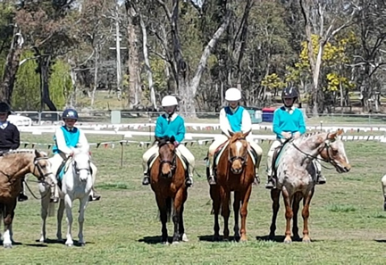

Phase 2 – Date TBC
Dates. Implementation of Phase two will be in line with NSW Public Health Orders.
Group Size. Group sizes remain 10 people but allows change of coach, instructor and helpers (still adhere to social distancing).
Bio-Security. GGPC will continue added bio-security procedures commensurate with NSW Public Health Order guidelines.
Health Orders. GGPC Officials and Members will adhere to NSW Public Health Orders which includes appropriate social distancing and safe hygiene practices.
PPE. GGPC will stock added PPE to include soap, hand sanitizer, gloves, toilet cleaning additional to current supply.
Facilities. Introduce use of club house – limited numbers, social distancing adhered to, stringent cleaning prior, during and after activities.
Lesson Equipment. No shared use of equipment, dedicated set up/pack up team (gloves on).
Member Health Declaration. All attendees will complete COVID19 PCANSW Self Declaration Form. Committee to document.
RSVP. Highly encourage all attendees to RSVP prior to attendance. Those that don’t RSVP are still required to register and complete induction administration to ensure committee documents everyone attending the activity.
COVID19 App. Recommend download and use for GGPC activities.
Canteen. Supply grab and go food. No sit down lunch or cooked food.

Phase 3 – Date TBC
Dates. Implementation of Phase three will be in line with NSW Public Health Orders.
Group Size. Group size returns to pre COVID19 numbers (socially distanced).
Bio-Security. GGPC will continue appropriate bio-security procedures commensurate with NSW Public Health Order guidelines.
Health Orders. GGPC Officials and Members will adhere to NSW Public Health Orders which includes appropriate social distancing and safe hygiene practices as appropriate.
PPE. GGPC will stock added PPE to include soap, hand sanitizer, gloves, toilet cleaning additional to current supply as required.
Facilities. Use of club house as per COVID19 – limited numbers, social distancing adhered to, stringent cleaning prior, during and after activities remains.
Lesson Equipment. Shared equipment allowed with gloves, dedicated set up/pack up team (gloves on), stringent cleaning prior, during and after use.
Member Health Declaration. All attendees will complete COVID19 PCANSW Self Declaration Form. Committee to document.
RSVP. Highly encourage all attendees to RSVP prior to attendance. Those that don’t RSVP are still required to register and complete induction administration to ensure committee documents everyone attending the activity.
COVID19 App. Recommend download and use for GGPC activities.
Canteen. Return to cooked/fresh lunches, sit down socially distanced.

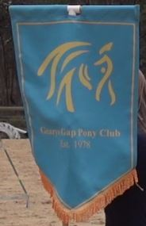

Enclosure 1
GGPC Activities Phase 1 commencing 13 July 2020 – Risk Management Assessment

Date of Event: _13 July 2020 Monthly Rally Days_____________ |  | Risk Management Team: __GGPC_________ Pony Club
Risk | Risk Rating | Control / Actions | Person Responsible
Attendees to confirm and sign Covid-19 declaration which states that they are well and have not had contact with anyone with COVID-19 | 1 | If rider and/or family members have been to Covid-19 affected areas, or been in contact with someone who has Covid-19 or shows symptoms of Covid-19 they may not attend and need to self-isolate for 14 days and unable to attend pony club until signed off by Doctor with a negative Covid-19 test result. | Self-monitoring and if necessary self-isolate– members must determine their own level of risk depending and their current health status
Contracting Covid-19 during travel to event – driving | 4 | Ensure that riders follow all guidelines produced by NSW Health on how to protect yourself – see NSW Health website and recommendations below. | Self-monitoring – members must determine their own level of risk depending and their current health status
Contracting Covid-19 – whilst at Pony Club | 4 | - GGPC have strict bio-security protocols in place for both riders and horses.  - All participants and support person/s attending grounds MUST complete Covid-19 declaration form and submit upon arrival – if participant and support person/s do not complete a form they must be asked to leave the grounds.  - Riders to follow all directions of Organising Committee  - Organising Committee will ensure that the venue has been cleaned prior to commencement maintained during the event  - Organising Committee to provide washing facilities and/or 60% alcohol based hand sanitizer  - Rider and other attendees to regularly wash hands/use hand sanitizer and social distance as per NSW Health regulations  - Riders and other attendees to follow all guidelines produced by NSW Heath on how to protect yourself – see below  - Minimise the use of equipment by riders/members or minimise the number of people setting up and packing down equipment to stop cross contamination. | - Organising Committee to oversee cleaning crews prior and during the event.  - Organising Committee to ensure that washing facilities are stocked with plenty of liquid soap and paper towel for all attendees  - Organising Committee to monitor hand sanitizer if being used to ensure that there is enough on hand  - Self-monitoring – members must determine their own level of risk depending and their current health status
If rider has concerns of possible contraction of Covid-19 | 2 | Follow NSW Health update on how the virus is spread and how long does Covid-19 last on surfaces - riders should follow all directions of Organising Committees and follow all guidelines produced by NSW Heath on how to protect yourself. | Self-monitoring – members must determine their own level of risk depending and their current health status
Gear Check – no contact to be made | 2 | - No contact by Gear Check Steward to rider or their equipment during Gear Check  - Rider (if old enough) or parent/responsible person to be on hand (one per rider only) during Gear Check to make any adjustments to gear as requested by Gear Check Steward | - Gear Check Steward  - Rider  - Parent/responsible adult
Contact between Instructors and rider – no contact to be made | 2 | - No contact by Instructor to rider or their horse during Rally Day.  - Parent and/or responsible adult to be on hand (one per rider only) to aid if needed. | - Instructor  - Organising Committee  - Parent/responsible adult
Contact between riders whilst mounted – no contact to be made | 2 | - Group numbers to be limited to so that the number of people on the ground or in a specified area do not exceed 10, who should be distanced accordingly to minimise the risk of contact from rider to rider whilst mounted.  - Riders to be advised that contact to be avoided both while mounted and unmounted  - Riders to arrive as scheduled – no more than half an hour prior to lesson  - Riders to leave as scheduled – no more than half an hour after lesson  - Riders may only have one adult/responsible person with them  - Total number of people in an area at any one time during Level 1 restrictions including riders, instructor, and parents must not exceed 10. Clubs may have more than one designated area for each group if space allows. Total number at any venue may not exceed 500.  - Clubs may not hold on ground competitions at this time to ensure total numbers are not exceeded. | - Instructor  - Organising Committee  - Parent/responsible adult
Response to fall of a rider | 3 | - The Organising Committee should appoint a dedicated First Aid person for the event  - The only people who may contact or respond to a fallen rider is the dedicated First Aid person or their parent/responsible adult  - All normal procedures regarding First Aid to be taken  - First Aider to always wear all appropriate PPE including mask and gloves  - Dedicated First Aider or another person authorised to act on their behalf should call an ambulance if necessary – please ensure that only one person calls, and that person has venue and patient details and information needed to help guide the ambulance to the venue | - Organising Committee  - Dedicated First Aider  - Parent/responsible adult
Parking, catering, use of facilities by people attending Rally Day | 2 | - Communicate with members to advise expectations at rally days  - Submitting self-screening forms  - Follow directions  - Determine who will speak to people showing symptoms of COVID-19  - Provision of PPE (masks, gloves, cleaning products) on hand for members to use, or members asked to bring their own.  - Signage throughout the venue on COVID-19 symptoms, good hygiene and social distancing 1.5m  - Vehicles spaces to be allocated with plenty of space between each vehicle  - Possible need for separate entry and exit points  - No canteen facilities - riders to bring own food and drink with no sharing of food or drink between riders or others on the grounds  - Riders need to be ready to ride other than gear check so that they are not on the grounds longer than needed for scheduling purposes  - No overnight stays  - All persons on grounds to adhere to strict social distancing guidelines 1.5m between people as detailed below  - Clubs rooms to remain closed unless needed to access bathrooms, if access needed please bunt off all areas except pathways into and out of bathrooms  - All persons on grounds to follow strict hygiene and hand washing procedures as detailed below  - Who will open and close gates – will need to schedule/allocate someone?  - Who will oversee taps – turning on and off etc. – or what PPE will be provided for people to clean as used?  - Who will oversee cleaning of toilets or will people be tasked with cleaning themselves once used and who will provide the cleaning equipment etc. (club or member)  - Provision of hand sanitizer for members and visitors to use. | - Organising Committee  - Parent/responsible adult  - Riders
Instructor travel and accommodation | 2 | - Where possible local Instructors to be used to limit travel and associated risks  - Where possible local Instructors to be used to limit accommodation needs, if accommodation needed ensure that accommodation is within restrictions | - Instructor  - Organising Committee
Venue Specific concerns – please list details here as necessary |  | List items that are specific to your club here/use as many pages as necessary | - Organising Committee

Signed: __________________________________________ Dated:_________________
Signed: __________________________________________ Dated:_________________

Enclosure 2

GGPC Signage during activities - Protect yourself
The best way to protect yourself from COVID-19 is the same way you would protect yourself from catching flu or other respiratory illness:
- wash your hands for at least 20 seconds with soap and water or use an alcohol-based sanitiser with at least 60% alcohol.
- cover your sneeze or cough with your elbow or with tissue.
- avoid close contact with people who are ill
- avoid touching your eyes, nose and mouth
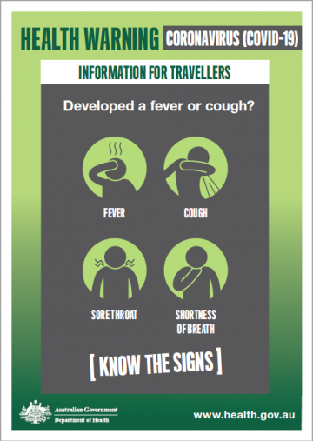
- stay home if you are sick.
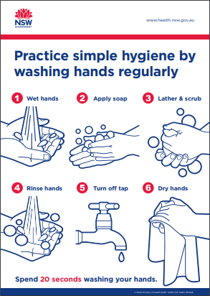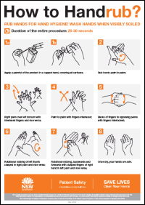
Call the National Coronavirus Health Information line 1800 020 080

For more information
Visit the NSW Health Website​
Enclosure 3
COVID19 Self Declaration Form

